**JAVAIRIA REHMAN**

**19P-0020**

**BS(CS) 19-5A**

**“computer networks lab”**

**Socket programming**

**Question 1**

**Solution**

**Socket programming in java console with tcp(two way communication)**

**Socket programming:**

Socket programming is **a way of connecting two nodes on a network to communicate with each other**. One socket(node) listens on a particular port at an IP, while other socket reaches out to the other to form a connection. Server forms the listener socket while client reaches out to the server.

**Socket programming using tcp ot udp:**

**UDP** is a connection-less, unreliable, datagram protocol (TCP is instead connection-oriented, reliable and stream based). There are some instances when it makes to use UDP instead of TCP. ... recvfrom returns the IP address of the client, along with the datagram, so the server can send a response to the client.

**Server code**

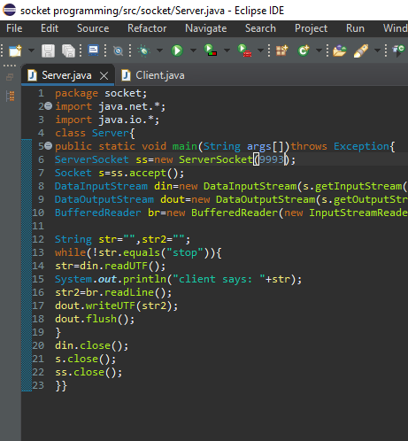

**Client code**

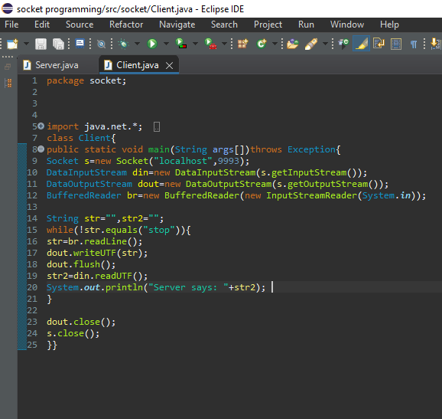

**Step by step output**

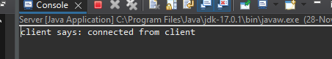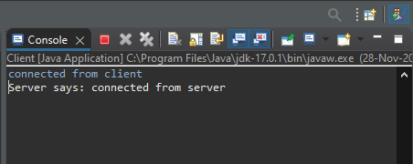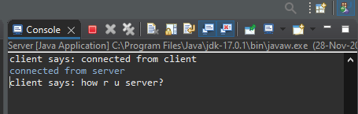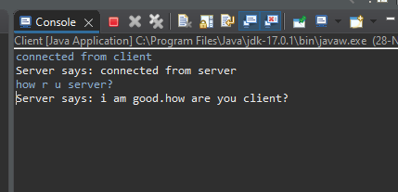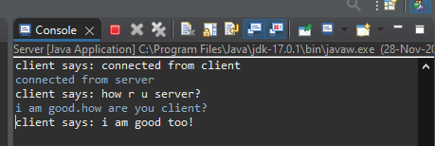

**Output explanation**

* Client sent message to server :connected from client
* Server sent message to client connected from server
* Client sent message to server :how are u server?
* Server sent message to client :I am good.how are u clinet?
* Client send message to server :I am good!

**Question 2**

**Solution:**

**Socket programming using ftp protocol in java for both client and server**

**Step1 code**

**server**

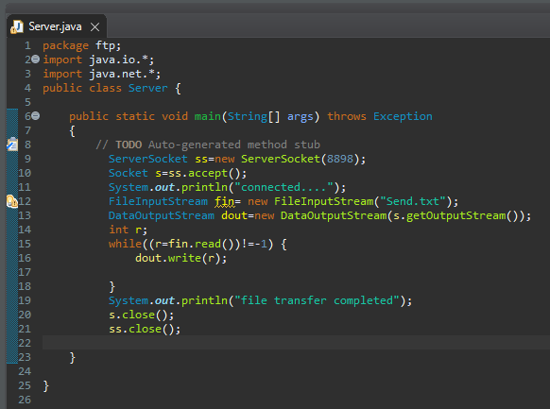

**Client**

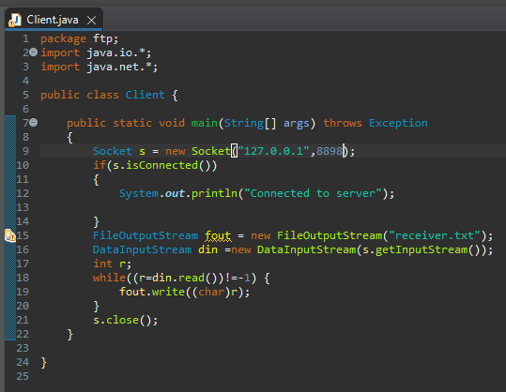

**Step 2 created file name(send.txt) in same directory of code**

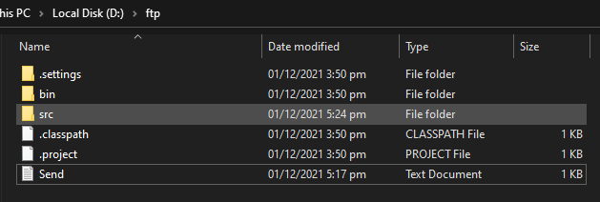

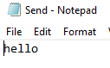

**Run server then clinet**

**Output**

**Client**

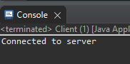

**Server**

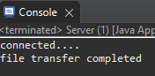

**File received in code directory as receiver.txt**

